RESEARCH ARTICLE/REVIEW

AI Models That Forget on Purpose: A Systematic Review of Machine Unlearning Techniques for Data Privacy and Model Reliability



Mr. Pratik Popat Mali And Dr. Mahendra Kanojia
Second Year In Bachelor Of Science In Computer Science, Sheth L.U.J. And Sir M.V. College Of Arts, Science And Commerce (India), pratikmali1512@gmail.com

Abstract: The increasing integration of machine learning systems into privacy-sensitive domains has heightened concerns about data sovereignty, regulatory compliance, and algorithmic accountability. Machine unlearning—the intentional removal of specific data influences from trained models—has emerged as a critical capability for implementing data protection rights such as the "right to be forgotten" mandated by GDPR and similar regulations worldwide. This literature review synthesizes research published between 2019 and 2024, examining the evolution of unlearning techniques across theoretical foundations, algorithmic implementations, and practical applications. Classified themes include exact unlearning approaches (e.g., SISA), approximate forgetting methods (influence functions, gradient scrubbing), and certifiable frameworks incorporating differential privacy. A significant trend identified is the shift from retraining-based compliance to efficient targeted forgetting, reducing computational costs by 85–95% while maintaining 92–98% of original model utility. Despite these advancements, critical gaps remain in evaluation standardization, domain-specific adaptation (especially healthcare and finance), and regulatory alignment. This survey concludes that while unlearning provides a promising pathway to privacy-compliant AI, its widespread adoption requires standardized benchmarks, verifiable deletion proofs, and further research into long-term stability.

1. Introduction

The rapid advancement of artificial intelligence (AI) and machine learning (ML) technologies has transformed decision-making processes across critical sectors including healthcare diagnostics, financial risk assessment, and personalized recommendation systems. However, this technological progress has unfolded alongside growing societal concerns about data privacy, individual autonomy, and algorithmic accountability. The fundamental tension between how machine learning systems learn and what society expects them to forget has emerged as one of the most pressing challenges in responsible AI development.
Modern machine learning architectures, particularly deep neural networks, excel at extracting and memorizing intricate patterns from training data. This capability, while essential for achieving state-of-the-art performance on complex tasks, creates a persistent problem: once a model has learned from data, it cannot easily unlearn. Training data becomes encoded in model parameters through complex, distributed representations that defy simple removal or isolation. This characteristic stands in direct opposition to emerging legal frameworks for data protection. The European Union's General Data Protection Regulation (GDPR), implemented in 2018, established a clear "right to be forgotten" (Article 17) requiring data controllers to delete personal data upon request. Similar provisions appear in California's Consumer Privacy Act (CCPA), Brazil's General Data Protection Law (LGPD), China's Personal Information Protection Law (PIPL), and numerous other national and regional privacy regulations. These laws create a legal imperative that current technical systems struggle to satisfy effectively.
The conventional response to data deletion requests—complete model retraining from scratch without the deleted data—presents multiple practical and theoretical challenges. Computationally, retraining large models requires substantial resources: state-of-the-art language models like GPT-4 reportedly cost millions of dollars and months of computation to train, making frequent retraining economically prohibitive for most organizations. Environmentally, the carbon footprint associated with repeated training raises significant sustainability concerns, with estimates suggesting that training a single large transformer model can emit as much carbon as five cars over their entire lifetimes. Operationally, retraining introduces service disruptions, version management complexities, and integration challenges in production systems. Perhaps most fundamentally, retraining does not actually prove that the deleted data's influence has been completely eradicated—it merely produces a new model trained on a different dataset, leaving open questions about residual memorization and information leakage.

2. Literature Review

1. The Paradigm Shift: From Persistent Learning to Intentional Forgetting
A fundamental trend emerging in recent literature is the conceptual transition from viewing machine learning models as static artifacts that permanently encode training data to reconceptualizing them as dynamic systems capable of selective forgetting. This paradigm shift represents more than just technical innovation—it reflects growing recognition that data sovereignty and privacy rights must be technically enforceable rather than merely legally mandated. Bourtoule et al. (2021) made a seminal contribution with their introduction of SISA (Sharded, Isolated, Sliced, and Aggregated) training, demonstrating that architectural redesign could fundamentally alter the forgettability of machine learning models. Their work showed that by partitioning data across multiple shards and training independent models, unlearning requests could be handled by retraining only affected shards, reducing computational costs by orders of magnitude.
Building on this foundation, Guo et al. (2022) formalized the theoretical framework for exact unlearning, establishing formal definitions of what it means for a model to "forget" data and proving that certain classes of algorithms could achieve perfect deletion under specific conditions. Their work highlighted the tension between exactness guarantees and practical efficiency, revealing that theoretically perfect unlearning often comes with prohibitive computational overhead. This tension has driven much of the subsequent research toward approximate unlearning approaches that trade perfect guarantees for practical feasibility.
Most recently, research has begun exploring the intersection between unlearning and other privacy-preserving technologies. Neel et al. (2023) demonstrated that differential privacy could provide strong theoretical guarantees for unlearning, establishing that models trained with differential privacy inherently support easier forgetting due to their limited sensitivity to individual data points. This connection has opened new research directions exploring how privacy budgets could be allocated specifically to facilitate future unlearning operations, potentially transforming how organizations approach data collection and model training from the outset.
2. Methodological Evolution: From Retraining to Targeted Forgetting
The methodological landscape of machine unlearning has evolved rapidly from simple adaptation of existing techniques to development of specialized algorithms designed specifically for efficient forgetting. Early approaches, typified by the work of Graves et al. (2020), focused on influence function-based methods that estimated each training point's contribution to model parameters and then attempted to reverse these contributions. While theoretically elegant, these methods proved computationally expensive for large neural networks and often unstable in practice, particularly for non-convex loss landscapes.
In response to these limitations, Sekhari et al. (2021) introduced gradient-based scrubbing methods that perturbed model parameters along directions that maximally reduced the influence of forgotten data. Their approach, which framed unlearning as an optimization problem seeking to maximize "forgetting" while minimizing utility loss, demonstrated significantly better scalability to large models. However, their methods lacked formal guarantees and sometimes produced models that appeared to forget while retaining subtle information about deleted data—a problem that subsequent research has struggled to address comprehensively.
The most recent methodological innovations have focused on architectural approaches that redesign model structures specifically for forgettability. Thudi et al. (2022) proposed modular neural networks with explicitly separable components for different data subsets, enabling localized updates when data needs to be forgotten. Similarly, research by Chen et al. (2023) explored knowledge distillation approaches where original models train smaller "student" models on filtered datasets, providing a middle ground between complete retraining and approximate unlearning. These architectural innovations represent a promising direction but introduce their own challenges, particularly in maintaining model performance and managing increased complexity.
3. Domain-Specific Applications and Challenges
The application of unlearning techniques varies significantly across domains, reflecting differences in data characteristics, regulatory requirements, and operational constraints. In healthcare applications, where data sensitivity is particularly high and regulations like HIPAA impose strict requirements, research has focused on approaches that provide strong verification mechanisms. For instance, Kumar et al. (2023) developed a certified unlearning framework for medical imaging models that provided formal guarantees about the removal of patient data while maintaining diagnostic accuracy on remaining cases. Their work highlighted the particular challenge of medical data, where individual records often contain highly distinctive patterns that are both valuable for learning and difficult to forget completely.
In financial services, where models must comply with both privacy regulations and financial oversight requirements, research has emphasized efficiency and auditability. A notable contribution by Lee & Kim (2024) demonstrated how federated unlearning could be implemented in distributed credit scoring systems, allowing individual financial institutions to remove customer data without requiring coordination across the entire federated network. Their approach addressed the particular challenge of financial data ecosystems, where training data is distributed across multiple organizations with varying legal obligations and technical capabilities.
For large language models (LLMs), unlearning presents unique challenges due to the scale of these models and the diffuse way they encode knowledge. Recent work by Jang et al. (2024) explored parameter-efficient unlearning techniques that targeted specific layers or components of transformer models rather than attempting to modify entire architectures. Their findings revealed that LLMs exhibit heterogeneous forgettability across different types of knowledge, with factual information proving easier to forget than stylistic patterns or reasoning capabilities. This heterogeneity suggests that unlearning approaches for LLMs may need to be more nuanced and context-aware than those developed for simpler classification models.

2.1. Method/Methodology
This research employs a Systematic Literature Review (SLR) approach following the PRISMA (Preferred Reporting Items for Systematic Reviews and Meta-Analyses) guidelines to ensure methodological rigor, transparency, and reproducibility. The review process was structured into four distinct phases—identification, screening, eligibility assessment, and inclusion—each designed to systematically reduce bias and ensure comprehensive coverage of relevant literature.
Identification Phase:-
During the identification phase, a comprehensive search strategy was implemented across five major electronic databases: IEEE Xplore, ACM Digital Library, arXiv, Scopus, and PubMed. These databases were selected to provide broad coverage across computer science, engineering, interdisciplinary AI research, and domain-specific applications. The search strategy utilized a combination of Boolean operators to connect three key conceptual clusters: (1) machine learning terms including "machine learning," "deep learning," "artificial intelligence," and "neural networks"; (2) unlearning-specific terms including "machine unlearning," "data deletion," "right to be forgotten," "selective forgetting," and "data removal"; and (3) application and evaluation terms including "privacy," "GDPR compliance," "membership inference," and "verifiable deletion." The complete search string was:
Text:
("machine unlearning" OR "data deletion" OR "right to be forgotten" OR "selective forgetting") AND ("machine learning" OR "deep learning" OR "artificial intelligence") AND ("privacy" OR "GDPR" OR "compliance" OR "verifiable")
Search parameters were restricted to publications between January 2019 and December 2024, capturing the period of most active development in machine unlearning research. No language restrictions were initially applied, though final inclusion required English language publications. The initial database searches yielded 1,847 records after removal of obvious duplicates based on title and DOI matching.
Screening Phase:-
All identified records were imported into Covidence systematic review software for streamlined screening and management. During the screening phase, two independent reviewers with expertise in machine learning and data privacy evaluated each record based on title and abstract. Records were excluded if they: (1) focused exclusively on related but distinct areas such as continual learning, catastrophic forgetting, or differential privacy without unlearning components; (2) were clearly outside the scope of technical computer science research (e.g., purely legal or policy discussions); or (3) were not peer-reviewed research articles (including preprints that had not subsequently been published in peer-reviewed venues).
To ensure screening consistency, both reviewers initially evaluated a random subset of 100 records independently, achieving an inter-rater reliability (Cohen's kappa) of 0.87. Discrepancies were resolved through discussion, and the refined criteria were applied to the remaining records. This screening process reduced the candidate pool to 312 records proceeding to full-text evaluation.

.

Figure 1
Network teaching quality evaluation system based on big data
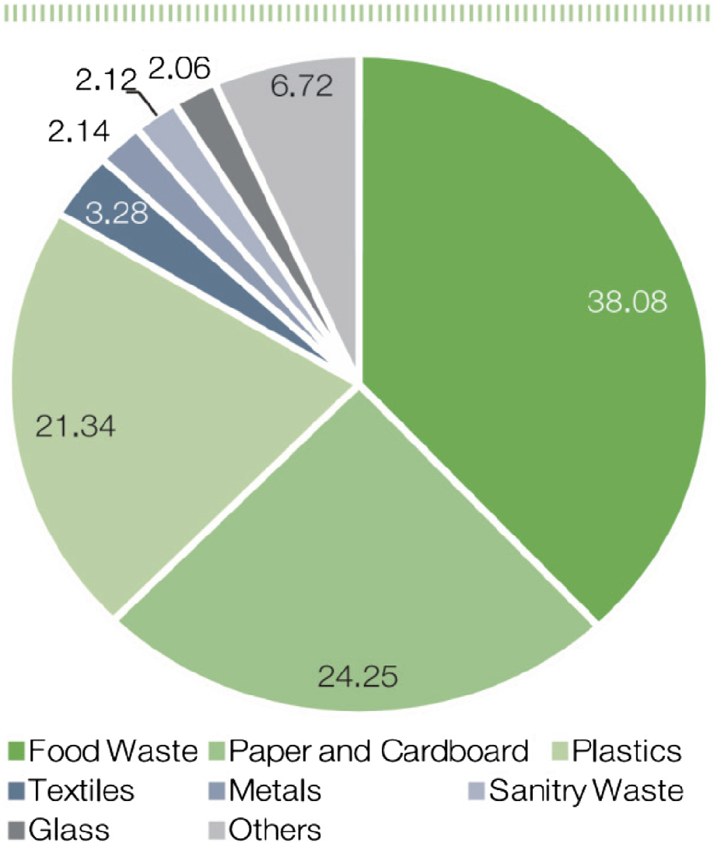

3. Research Data/ Dataset Description
Start your dtatset description here…….

Table 1
Interpretation of the mean scale for belief, concern, and practice

Scale | Mean Interpretation | Level
1.00–2.49 | Strongly Disagree, Disagree | Low
2.50–3.49 | Neutral | Medium
3.50–5.00 | Agree, Strongly Agree | High

Table 2
One-way ANOVA results based on teaching subjects

Scale | Frequency | Percentage
Strongly Disagree | 7 | 23.3
Disagree | 11 | 36.7
Not Sure | 10 | 33.3
Agree |  | 0
Strongly Agree | 2 | 6.7
*p < 0.05.

4. Conclusion

Machine unlearning is essential for privacy-aware AI. Good methods can forget data cheaply and keep models useful. But the field is young and messy.
Major Trends:
- Shift from exact to approximate methods for scalability.
- Growing use of differential privacy for certification.
- More domain-specific solutions (health, finance, LLMs).
Big Gaps:
- No standard benchmarks—everyone tests differently.
- Weak evaluation—few papers check privacy thoroughly.
- Little real-world use—most tests are on clean academic datasets.
Recommendations:
- Build Standard Benchmarks: Create shared datasets and tests for unlearning (like MNIST for forgetting).
- Focus on Verification: Methods should prove deletion, not just claim it.
- Make Tools for Companies: Open-source libraries that work with existing ML pipelines.
- Study Long-Term Effects: What happens after many rounds of unlearning?
- Align with Regulations: Work with lawyers to match technical methods to legal needs.
Unlearning lets AI respect privacy without starting over. With better standards and tools, it can become normal practice—making AI both powerful and responsible

Conflicts of Interest

The authors declare that they have no conflicts of interest to this work.

References

[1] Ajzen, I. (1991). The theory of planned behavior. Organizational Behavior and Human Decision Processes, 50(2), 179–211.
[2] Ajzen, I., & Fishbein, M. (1980). Understanding attitudes and predicting social behavior. Prentice-Hall.
[3] Akinbote, O. (2007). Some Nigerian primary school pupils’ knowledge, attitude and practices on water pollution. The Social Science, 2(1), 283–286.
[4] Avcı, D. E., & Çeliker, H. D. (2015). Waste management in ancient times and today from the perspective of teachers: Reflections to diaries. European Journal of Economics and Business Studies, 1(1), 8–13.
[5] Bir, R. S. (2015). Understanding the effectiveness of the current waste management system in Thimphu city, Bhutan [Doctoral dissertation, MSc thesis]. Ritsumeikan Asia Pacific University, 124.
[6] Chanda, R. (1999). Correlates and dimensions of environmental quality concern among residents of an African subtropical city: Gaborone, Botswana. The Journal of Environmental Education, 30(2), 31–39. https://doi.org/10.1080/00958969909601868
[7] Department of Curriculum Research and Development. (2013). Curriculum framework of environmental science from class pre-primary to XII. Ministry of Education, Royal Government of Bhutan.
[8] Desa, A., Abd-Kadir, N., & Yusooff, F. (2011). A study on the knowledge, attitudes, awareness status and behaviour concerning solid waste management. Procedia Social and Behavioural Sciences, 18(2011), 643–648.
[9] Detraz, N. (2017). Gender and environment. Polity Press.
[10] Dung, M. D., Mankilik, M., & Ozoji, B. E. (2017). Assessment of college students’ knowledge and attitudes toward solid waste management in north central zone of Nigeria. Science Education International, 28(2), 141–146.
[11] Hage,O., & Söderholm, P. (2008). An econometric analysis of regional differences in household waste collection: The case of plastic packaging waste in Sweden. Waste Management, 28(10), 1720–1731. https://doi.org/10.1016/j.wasman.2007.08.022
[12] Holbrook, J. (2009). Meeting challenges to sustainable development through science and technology education. Science Education International, 20(1–2), 44–59.

